Name of the Speaker: Dr. Mukesh Gautam
Date: 5th October 2017
Start Time: 10am
End Time: 11:15 am
Aim.
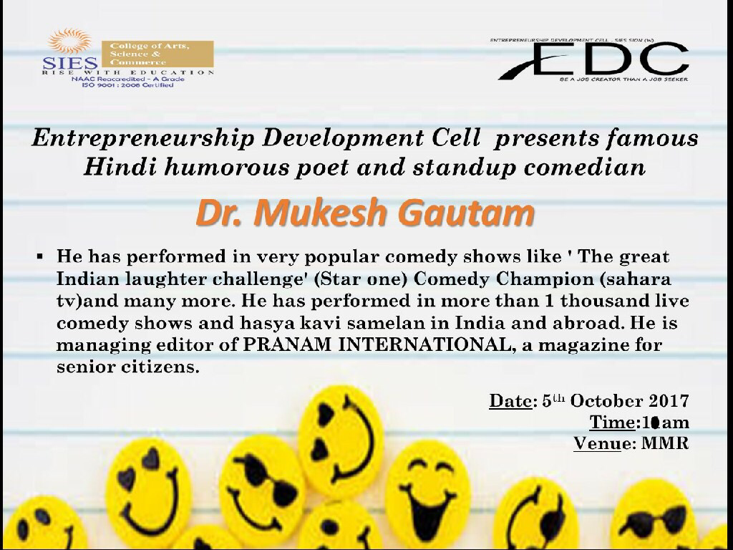
The primary aim for conducting this event was to bring a globally acknowledged Poet and stand up comedian to share his life stories and explain to the students how the poem and the stand up comedy industry works in India.

About the event.
The entire event was extremely well organized and executed by the entire Board of directors of the ‘Entrepreneurship Development Cell’ and attended by the more than 100 students including the EDC members and the BOD. It was also graced by the presence of our very own convener of EDC Prof. Anita Agrawal , Principal Dr. Uma Shankar and Prof. Pathak. Dr. Mukesh Gautam through his poems was able to send a message to the students that no matter what we should always remain positive and keep smiling. He was also able to covey to the students through his poems that we should always stay humble and down to earth.
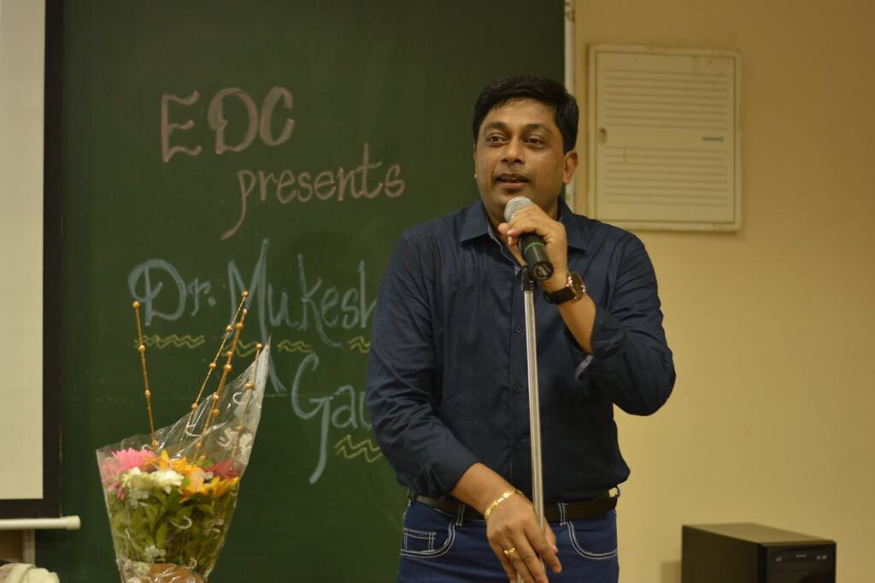

Summary.
By the end of the event every student in the audience was laughing because of the the jokes told by Dr. Mukesh Gautam. And through his poems he was able to deliver important life lessons to the Students.
